Laboratory Assignments
Subject: Design Principles of Operating Systems
Subject code: CSE 3249
Assignment 5: Implementation of synchronization using semaphore:
Objective of this Assignment:
- To implement the concept of multi-threading in a process.
- To learn the use of semaphore i.e., to control access to shared resources.

- Producer-Consumer problem
Problem: Write a C program to implement the producer-consumer program where:
- Producer generates integers from 1 to 50.
- Consumer processes the numbers.
Requirements:
- Use a shared buffer with a maximum size of 10.
- Use semaphores and mutex to ensure thread-safe access to the buffer.
- Print the number that producer is producing and consumer is consuming.
- Both producer and consumer will continue for 20 iterations
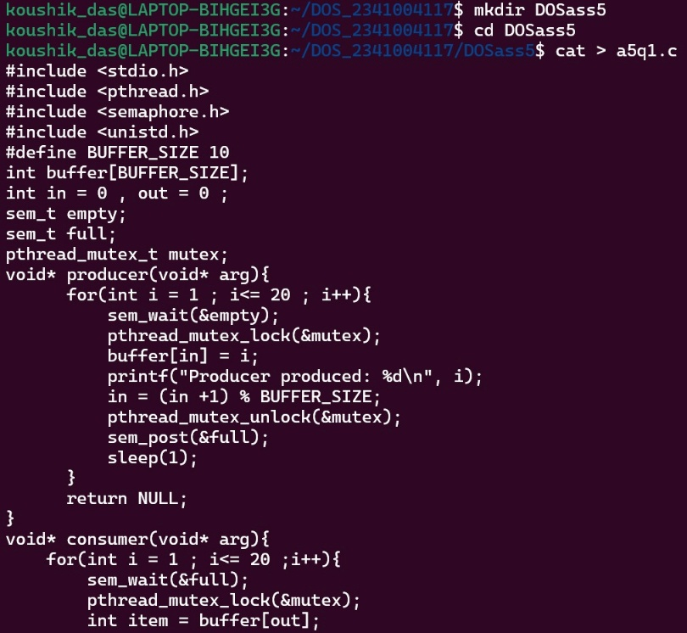
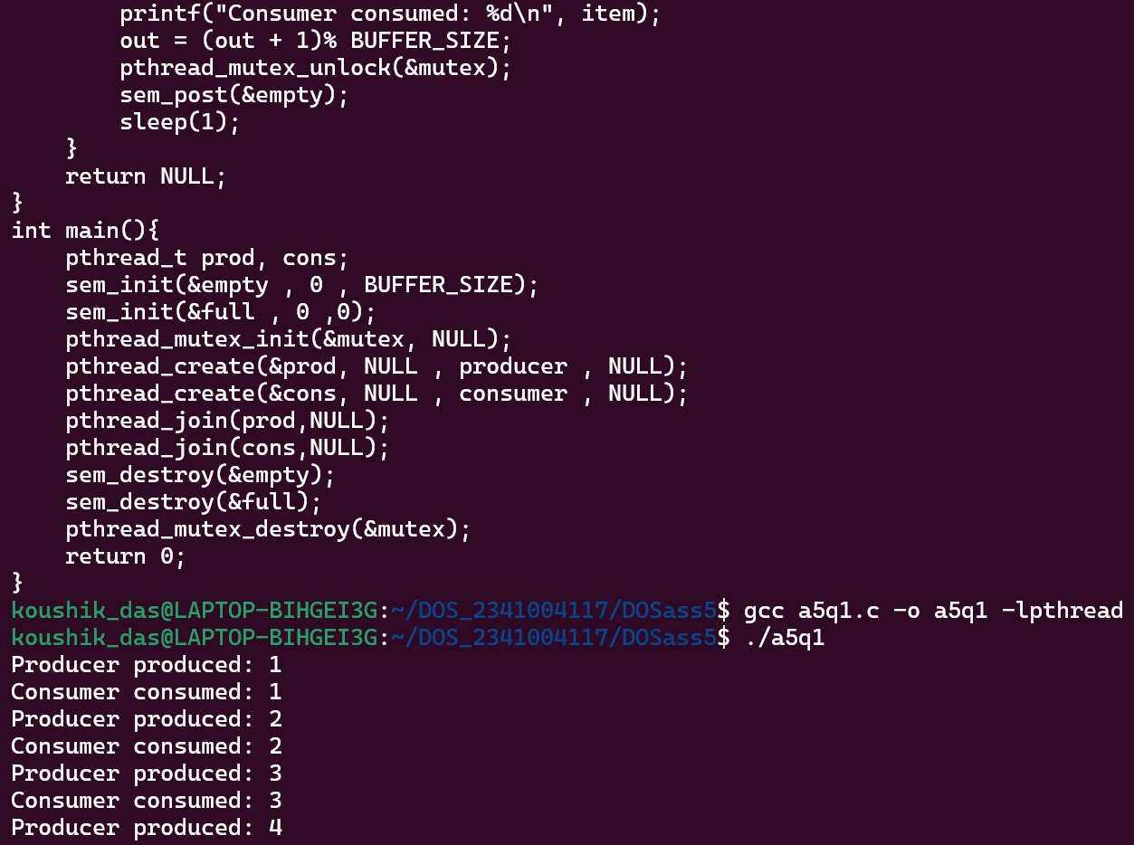
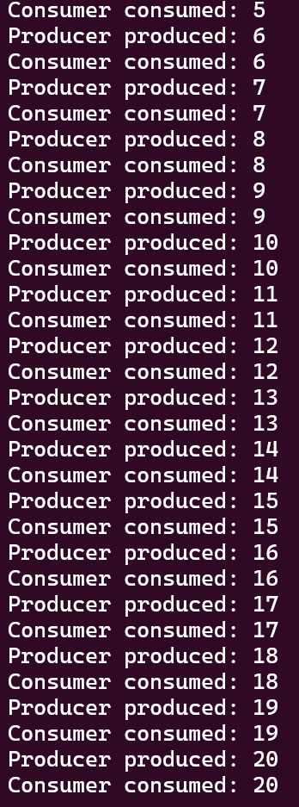
- Alternating Numbers with Two Threads
Problem: Write a program to print 1, 2, 3 … upto 20. Create threads where two threads print numbers alternately.
- Thread A prints odd numbers: 1, 3, 5 ...
- Thread B prints even numbers: 2, 4, 6 ...
Requirements:
• Use semaphores to control the order of execution of the threads.
• Ensure no race conditions occur.
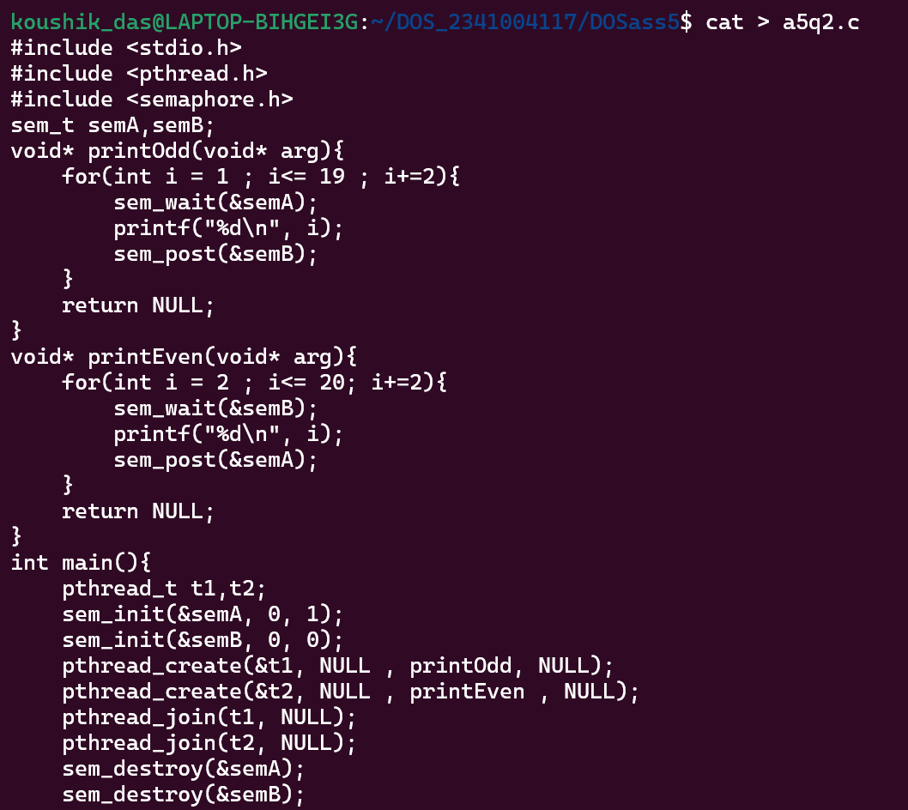
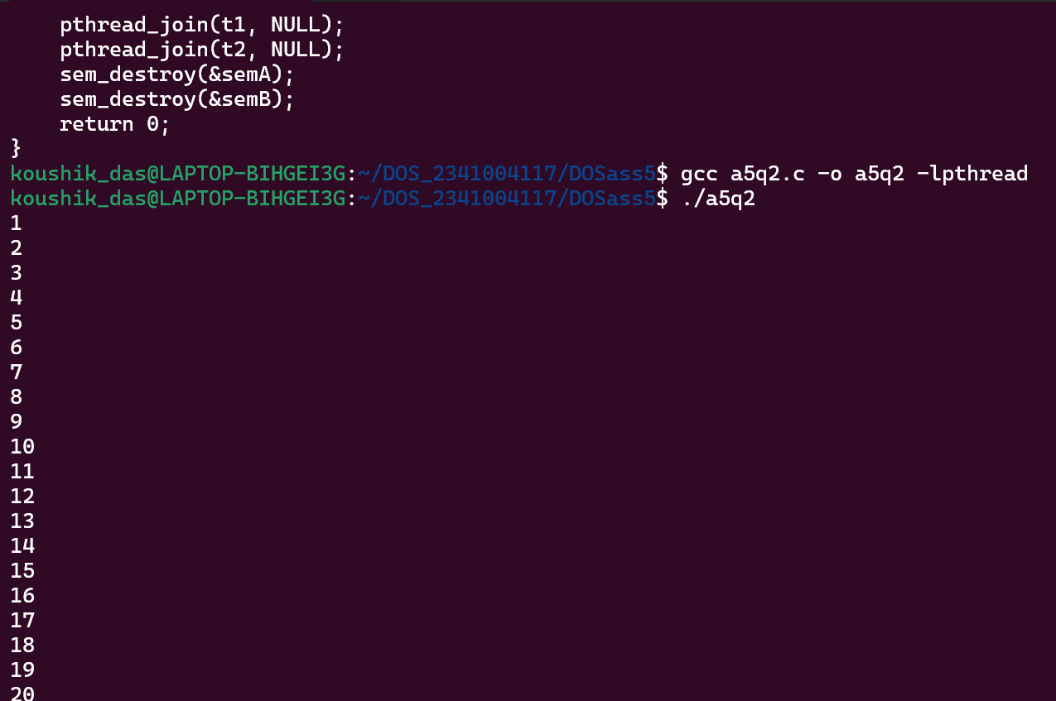
- Alternating Characters
Problem: Write a program to create two threads that print characters (A and B) alternately such as ABABABABA…. upto 20. Use semaphores to synchronize the threads.
- Thread A prints A.
- Thread B prints B.
Requirements:
- Use semaphores to control the order of execution of the threads.
- Ensure no race conditions occur.
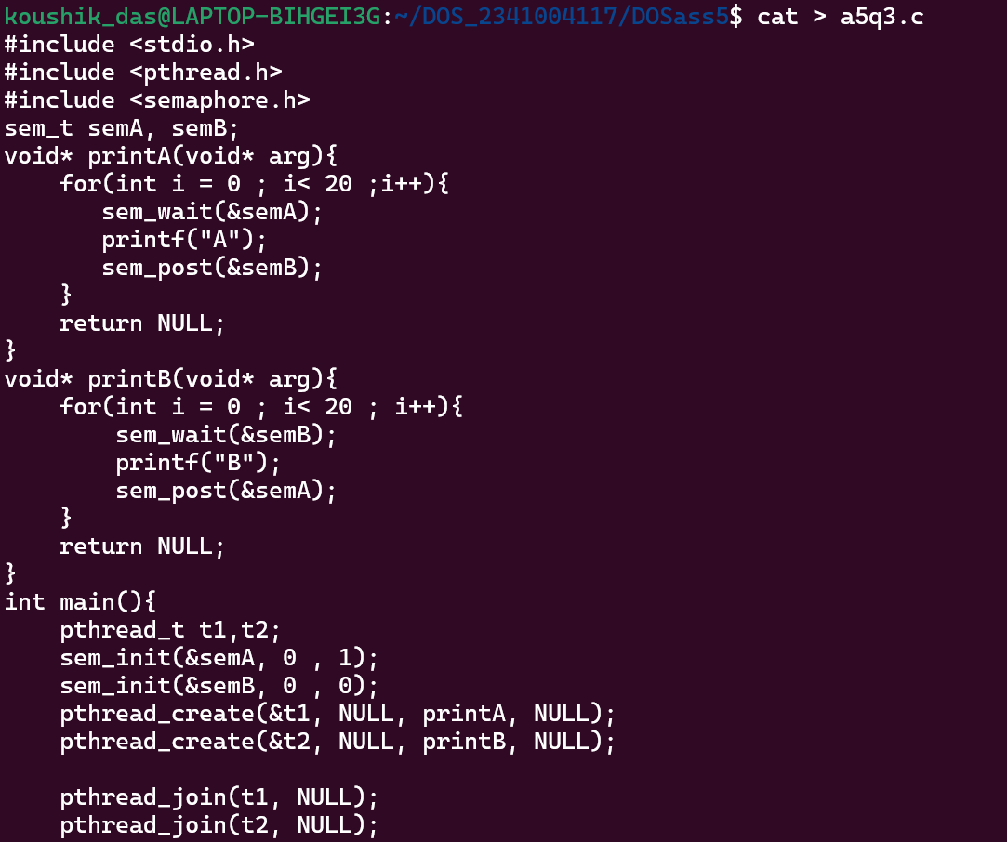
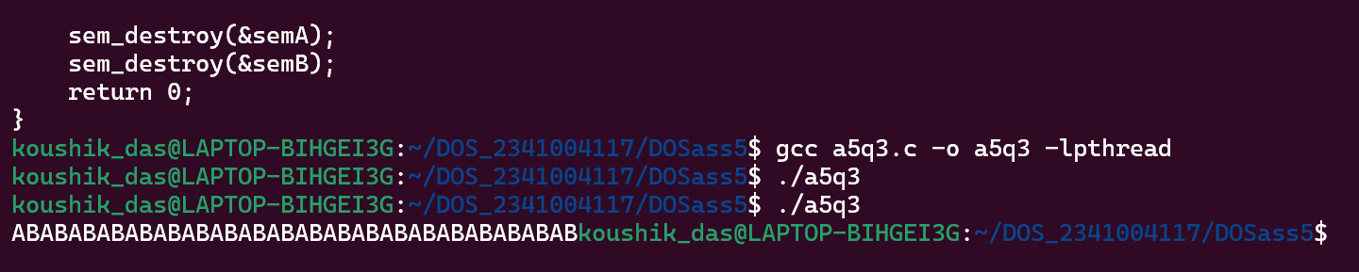
- Countdown and Countup
Problem: Write a program create two threads where:
- Thread A counts down from 10 to 1.
- Thread B counts up from 1 to 10. Both threads should alternate execution.
Requirements:
- Use semaphores to control the order of execution of the threads.
- Ensure no race conditions occur.
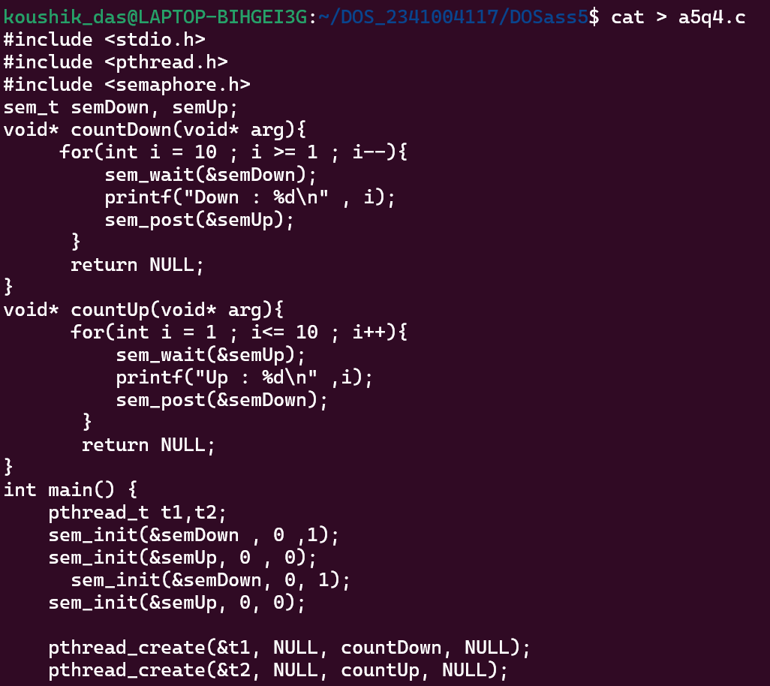
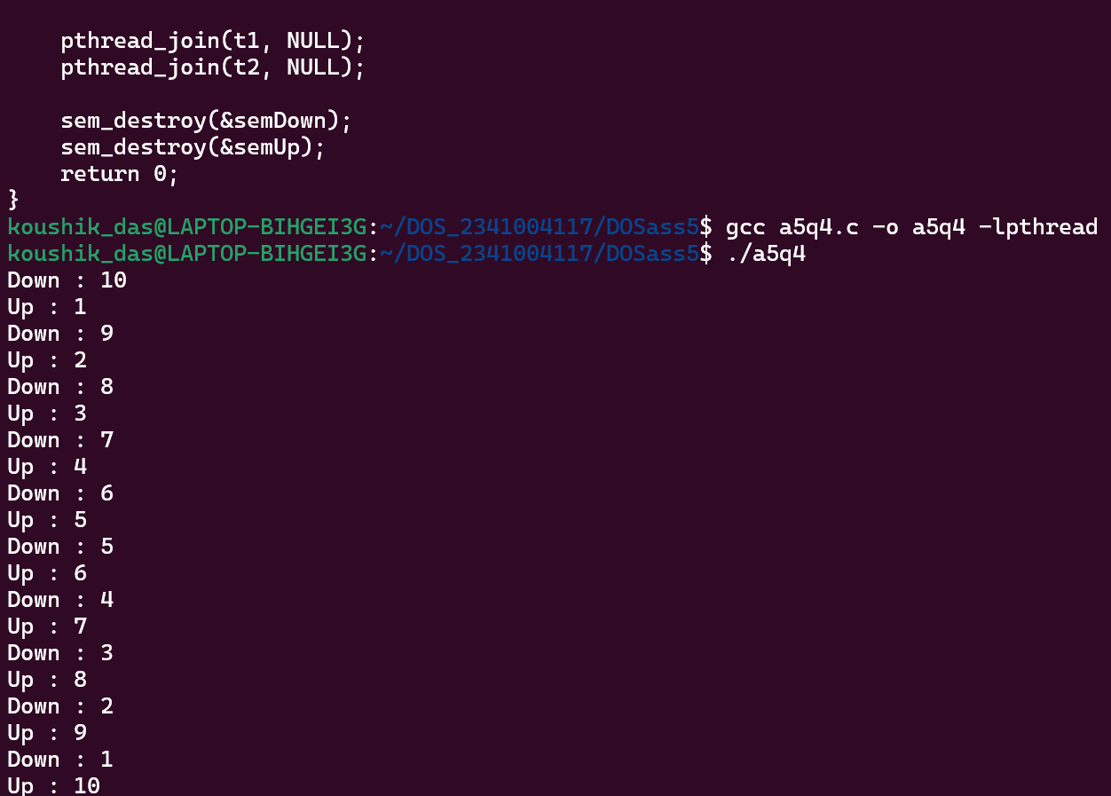
- Sequence Printing using Threads
Problem: Write a program that creates three threads: Thread A, Thread B, and Thread C. The threads must print numbers in the following sequence: A1, B2, C3, A4, B5, C6 … upto 20 numbers.
- Thread A prints A1, A4, A7, …
- Thread B prints B2, B5, B8, …
- Thread C prints C3, C6, C9, ...
Requirements:
- Use semaphores to control the order of execution of the threads.
- Ensure no race conditions occur.
